Effects of type of acid and polyvinyl alcohol on the physicochemical properties of acyclovir-loaded chitosan-based films
Pimpichaya Sangchart^{1, 2,}*, Jiraphong Suksiriworapong^{2, 3}, Anchalee Jintapattanakit^{2, 3}, Doungdaw Chantasart^{2, 3,}#
¹ Master of Science in Pharmacy Programme in Pharmaceutics (International Programme)
² Department of Pharmacy, Faculty of Pharmacy, Mahidol University, Bangkok, Thailand
³ Center of Excellence in Innovative Drug Delivery and Nanomedicine, Faculty of Pharmacy, Mahidol University, Bangkok, Thailand
e-mail: *spimpichaya@hotmail.com, #doungdaw.cha@mahidol.ac.th

Abstract
Acyclovir is an effective and selective agent against herpes viruses. Acyclovir is poorly absorbed from the gastrointestinal (GI) tract and undergoes first-pass metabolism. Transbuccal delivery of acyclovir is an alternative approach to avoid these problems. Buccal films are flexible and more accepted by patients than buccal tablets. In this study, chitosan and polyvinyl alcohol (PVA) were used as mucoadhesive polymers because of their good biocompatibility, biodegradability and low toxicity. The objectives of this study were to determine the effects of type of acid (acetic and lactic acids) used as a plasticizer and PVA on physicochemical properties of acyclovir-loaded chitosan films. Acyclovir mucoadhesive films were developed for buccal delivery. Films were prepared by solvent casting method. Mechanical properties of films were evaluated by a texture analyzer. Water-uptake study was measured by an increasing weight of sample after incubating in water at the predetermined time. The films with lactic acid showed more flexible and elastic than those with acetic acid. The films of chitosan blended with PVA had higher tensile strength and elongation than pure chitosan films. Furthermore, acyclovir-loaded films could increase the percent water-uptake of the films compared to the unloaded films which were possibly attributed to the increasing hydrophilic molecules in the films. The results of this research may be beneficial for further development of acyclovir mucoadhesive films for buccal delivery.

Keywords: film, chitosan, polyvinyl alcohol, acyclovir, acid

Introduction
Acyclovir is one of the most effective and selective agents against herpes viruses. It is widely used in the treatment and prophylaxis of herpes simplex virus type 1 (HSV 1) and type 2 (HSV 2) (1). After an oral administration, acyclovir is poorly absorbed from the gastrointestinal (GI) tract and undergoes first-pass metabolism. Thus, its oral bioavailability is low and variable ranging approximately 10-30% and decreases with increasing doses (2-4). To overcome its stated problems, transbuccal delivery of acyclovir is a promising approach.
Buccal delivery is an alternative route to avoid acid hydrolysis in GI tract and bypass hepatic first-pass metabolism. Various mucoadhesive buccal devices have been developed including tablets, films, patches, disks, ointments, and gels. Films are more flexible and accepted by patient than tablets. They also ensure more accurate dosing of the drug compared to gels and ointments (5). The buccal film should be flexible, elastic and soft. Therefore, plasticizers may be required. The common plasticizers used in mucoadhesive buccal films such as glycerin, propylene glycol, and polyethylene glycol 400.
Chitosan, a modified natural carbohydrate polymer derived from chitin, is classified as natural and cationic mucoadhesive polymer (6). It has been increasing importance in the pharmaceutical field due to its good biocompatibility, biodegradability and low toxicity (7). Chitosan can be prepared by cleavage of N-acetyl groups of chitin by treatment with strong alkali. When the degree of deacetylation (DD) of chitin reaches about 50% (depending on the origin of polymer), it becomes soluble in acidic aqueous media and so-called chitosan. It is insoluble in organic solvents, water, or alkaline solution at pH level above 6.5. It can be dissolved in dilute solutions of most acids such as acetic, lactic, citric and tartaric acids (8). Chitosan was first introduced in 1994 by JH. Guo for its use in mucoadhesive film formulation (9). Due to its good mucoadhesive, chitosan has been employed in mucosal site-specific systems. Moreover, chitosan has shown to be a potential penetration enhancer for the transmucosal (intestinal, nasal, buccal and vaginal) absorption of hydrophilic macromolecular drugs.
Polyvinyl alcohol (PVA) is a nontoxic, water-soluble synthetic polymer and has good film forming ability, physical and chemical properties. It has been used in many applications such as ophthalmic formulations, sustained release formulations, films, transdermal patches, and other drug delivery systems (10).
Due to the fact that chitosan can be dissolved in various acids, types of acid may affect the physicochemical properties of chitosan films. In addition, PVA may modify the mechanical, physicochemical and mucoadhesive properties of chitosan films. Therefore, the aim of this study was to investigate the effects of type of acid (acetic and lactic acids) used as a plasticizer and PVA on physicochemical properties of acyclovir-loaded chitosan-based films.
Methodology
Materials
Acyclovir (Zhejiang Chario Teer, China) was donated from Biolab Co., Ltd. (Bangkok, Thailand). Chitosan (Molecular weight 100 kDa, 95%DD, shrimp shell) was purchased from Bio21. Co., Ltd. (Bangkok, Thailand). PVA, sodium chloride (NaCl) and potassium phosphate monobasic (KH₂PO₄) were purchased from Carlo Erba Reagenti (Milan, Italy). Analytical grade lactic acid and sodium phosphate dibasic (Na₂HPO₄) were purchased from Ajax Finechem (New South Wales, Australia). Analytical grade glacial acetic acid was purchased from Labscan Co., Ltd. (Bangkok, Thailand). Sterile water for injection was purchased from Thai Nakorn Patana Co., Ltd. (Bangkok, Thailand). High performance liquid chromatography (HPLC) grade methanol was purchase from B&J (Ulsan, Korea). Simulated saliva fluid (SSF) pH 6.75 was prepared by dissolving 8.00 g of NaCl, 0.19 g of KH₂PO₄, and 2.38 g of Na₂HPO₄ in 1000 mL distilled water and pH was adjusted with phosphoric acid.
Preparation of films
Films were prepared by solvent casting method. The compositions of all formulations are summarized in Table 1. Briefly, 2% w/v of polymer or blended polymer was dissolved in 2% v/v acid. For acyclovir-loaded films, acyclovir was firstly dissolved in 2% v/v acid. The polymer was then added to the drug solution and stirred until it became clear. The mixture was poured into 8-cm diameter petri-dish and allowed to evaporate the solvent at 50 ○C in an oven for 24 h. The resultant amount of acyclovir in all casted films was 1 mg/cm².
Table 1. The compositions of chitosan films and chitosan blended PVA films
Formulations | Polymers | Acids | Acyclovir (mg)
F1 | CH | acetic acid | -
F2 | CH | acetic acid | 50
F3 | CH | lactic acid | -
F4 | CH | lactic acid | 50
F5 | CH:PVA (50:50) | lactic acid | -
F6 | CH:PVA (50:50) | lactic acid | 50
CH is chitosan, PVA is polyvinyl alcohol
Characterizations of films
Thickness of films
The thickness of films was determined by a micrometer (Ajax Scientific; Fisher, USA). The average of 10 determinations was calculated.
Weight variation
For the determination of weight variation of films, a 2.27 cm² disc (1.7 cm in diameter) of each film was randomly selected and accurately weighed using an analytical balance (BP 211D; Sartorius, Germany). The results were expressed as the mean value of 10 determinations.
Content uniformity
The uniformity of drug in the casted films was evaluated by determining drug content at different areas of the film. The dried film was randomly cut into circles with a diameter of 2.27 cm², and accurately weighed. A weighed film was dissolved in HPLC mobile phase. The drug content of ten samples was then determined by HPLC.
Mechanical properties
The mechanical properties of films including tensile strength and elongation at break were evaluated using a texture analyzer (TA.XT Plus; Swantech, Gennevilliers, France) equipped with a 5 kg load cell. The film was cut into a strip with a dimension of 10 mm in width and 50 mm in length. The strip film was held between 2 clamps positioned at a distance of 3 cm. During measurement, the film was pulled by top clamp at a rate of 0.5 mm/s to a distance that the film was broken before returning to the starting point. The force and elongation were measured when the film was broken. The tensile strength was determined as the force applied to produce the deformation of film per unit area (Eq. 1). The elongation at break was the distance of the upper plate moved up to the point of film separation compared to the original length (Eq. 2) (11, 12).
$\text{Tensile strength} \text{=} \frac{\text{The f}\text{orce at breaking}}{\text{A c}\text{ross-sectional area of the film}}$ (Eq. 1)

$\text{Elongation at break} \text{=}\frac{\text{An i}\text{ncrease}\text{d}\text{ length at break}}{\text{An i}\text{nitial film length}}\text{ × 100}$ (Eq. 2)
In vitro water-uptake study
The in vitro water-uptake study was performed in SSF pH 6.75 by measuring an increasing weight of the sample at the predetermined time (13). A 2.27 cm² disc with 1.7 cm in diameter of each film was weighed (W₁) and immersed in SSF for 1, 5, 10, 15, 30, 60, 120 min. An excess SSF was removed and wiped off from the sample by filter paper. The swollen film was accurately weighed (W₂). Then, it was dried in an oven at 50 °C for 24 h, allowed to cool in a desiccator, and weighed again (W₃). The water-uptake ability was determined as an increasing weight of film, according to Eq. 3:
$\text{WU (\%) = }\frac{\text{W}\text{2}\text{ – W}\text{1} }{\text{W}\text{1}}\text{ ×100}$ (Eq. 3)

where W₁ and W₂ are the initial weight of dry film and the weight of swollen film, respectively.
The film erosion (ES) at different times is estimated from the following equation:
$\text{ES (\%) =} \frac{\text{W}\text{1} \text{-} \text{W}\text{3}}{\text{W}\text{1}}\text{ ×100}$ (Eq. 4)
where W₃ is the weight of film after drying at 50 °C.
HPLC analysis
The quantity of acyclovir was determined by HPLC (Agilent 1200 series, USA). Twenty microliters of samples was injected into the HPLC system. A Thermo Scientific® column with a guard column (BDS Hypersil C18, 5 µm, 150×4.6 mm) was used as a stationary phase while the mixture of glacial acetic acid and water (1:1000 v/v) at a flow rate of 1.3 mL/min was used to elute the drug from the stationary phase. The detection wavelength was 251 nm. The standard solution was prepared in a mobile phase and used to construct a calibration curve based on peak area measurement. The samples were appropriately diluted in the mobile phase for subsequent analysis.
Statistical analysis
Statistical analysis data were expressed as the mean ± standard deviation (SD). Paired sample t-test was used to compare the values between 2 formulations. The p-value of less than 0.05 (p-value < 0.05) was considered statistically significant.
Results
Table 2 illustrates the thickness, weight variation, tensile strength, elongation at break and drug content of each formulation. The thicknesses in all formulations were in the range of 0.095-0.120 mm and weight variations were 32.12-34.80 mg/2.27 cm².
Effect of type of acid used as a plasticizer
To study the effect of type of acid used as a plasticizer, F1 and F3 formulations were compared. As shown in Table 2, acetic acid gave the highest tensile strength (50.818 N/mm²) but the lowest percentage of elongation (8.05%) of film. However, the added drug could not be completely dissolved in the casted film (F2 formulation). Meanwhile, when adding acyclovir in F3 formulation corresponding to F4 formulation, no statistically significant difference of tensile strength and elongation between F3 and F4 formulations was observed. Therefore, F3 and F4 were further used to investigate the effect of PVA and the in vitro water-uptake.
Effect of PVA
To determine the effect of PVA, F3 (chitosan) and F5 (chitosan blended with PVA) formulations were compared. PVA significantly increased tensile strength and %elongation of the casted films. Once acyclovir was loaded in the films, the drug did not affect both characters of films (F4 and F6 compared to F3 and F5 formulations, respectively, p-value > 0.05). The increase in mechanical properties of films by PVA was due to intermolecular interaction between two polymers. Percentages of drug content of F4 and F6 formulations were 94.42% and 96.06%, respectively.
Table 2. Thickness, weight variation, tensile strength, elongation at break and drug content of chitosan and chitosan blended PVA films
Formulations | Thickness (mm)  (n=10) | Weight variation (mg)  (n=10) | Tensile strength (N/mm²)  (n=10) | % Elongation  (n=10) | % Drug content  (n=10)
F1 | 0.108±0.01 | 34.56±3.16 | 50.8180±2.72 | 8.05±0.80 | N/A
F2 | N/A | N/A | N/A | N/A | N/A
F3 | 0.118±0.01 | 34.80±4.90 | 1.1749±0.18 | 128.69±8.62 | N/A
F4 | 0.120±0.01 | 33.91±3.04 | 1.1073±0.09 | 127.21±8.20 | 97.42±1.44
F5 | 0.102±0.02 | 33.25±3.14 | 3.5264±0.52 | 441.49±83.10 | N/A
F6 | 0.095±0.01 | 32.12±4.14 | 2.7707±0.06 | 478.51±31.04 | 96.06±3.31

Percentages of water-uptake and erosion are presented in Figures 1 and 2, respectively. The results showed that each formulation swelled rapidly within 5-15 min to reach the maximum water-uptake after immersing the films in the medium. Comparing between F3 and F5, PVA led to the decrease in water-uptake. The addition of acyclovir to chitosan films (F4 formulation) resulted in higher maximum percentage of water-uptake than that of F3. In case of F5 and F6 formulations, although F6 illustrated less water-uptake than that of F5, in fact, it swelled, dissolved rapidly and became gel. It was unable to be kept up from SSF for reweighing after 5 min of testing. Therefore, the percentage of water-uptake of F6 was the lowest due to the lost film during testing process. The percentage of film erosion of F3, F4, and F5 formulations was in the same trend. For F6 formulations, it reached 79% in 5 min. This result was well agreed with the water-uptake study.

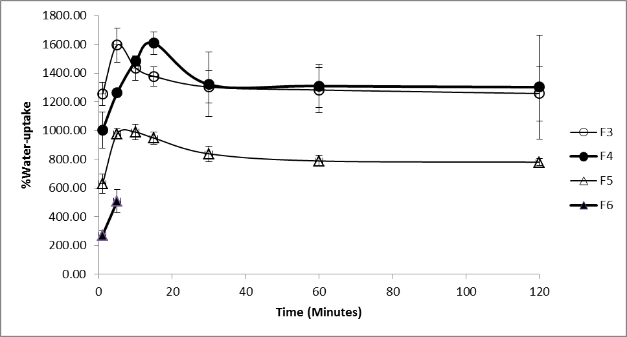
Figure 1. Percentage of water-uptake study versus time profiles of F3, F4, F5, and F6

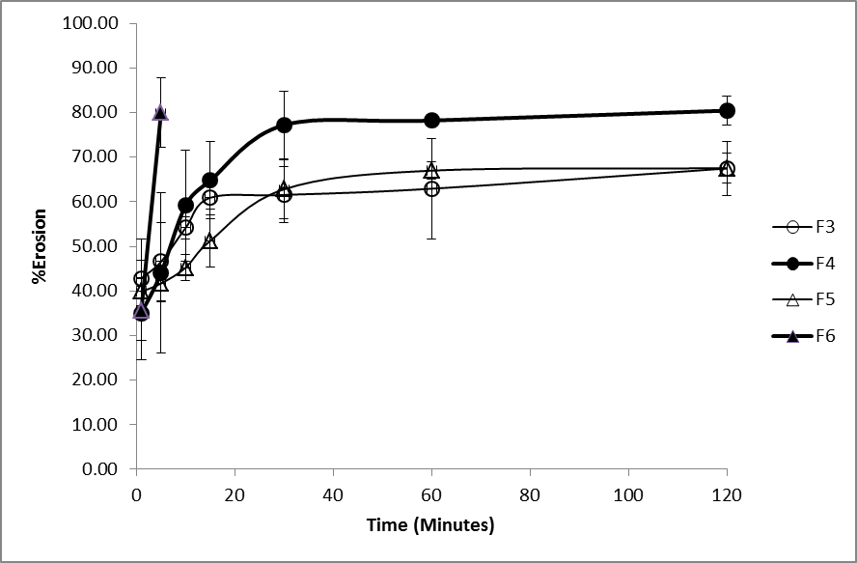
Figure 2. Percentage of erosion versus time profiles of F3, F4, F5, and F6
Discussion and Conclusion
The mechanical properties of chitosan films showed that acetic acid (F1) could provide the harder and stronger film than lactic acid (F3 and F4), indicated by the tensile strength. However, lactic acid provided more flexible and elastic films because of its plasticizer characteristics (14). For chitosan blended PVA films (F5 and F6), the results indicated that the blended films had higher tensile strength and elongation than chitosan films (F3 and F4). The results are in agreement with Parida et al. (15) that blending of chitosan and PVA led to an intermolecular interaction between hydroxyl (-OH) and amino (-NH₂) groups of two polymers and thus improved mechanical strength of the films. Furthermore, acyclovir-loaded films showed the increased water-uptake as compared to the unloaded one. The results suggested that the hydrophilic groups from the drug could increase the water-uptake of the films.
References

1. Sweetman SC, editor. Martindale: The complete drug reference. 36th ed. London: The Pharmaceutical Press; 2009.

2. Healthcare T, editor. Drug information for the health care professional. 27th ed: Thomson Micromedex; 2007.

3. Shojaei AH, Zhou SL, Li X. Transbuccal delivery of acyclovir (II): feasibility, system design, and in vitro permeation studies. J Pharm Pharmaceut Sci 1998; 1(2):66-73.

4. Susantakumar P, Gaur A, Sharma P. Comparative pharmacokinetics, safety and tolerability evaluation of acyclovir IR 800 mg tablet in healthy indian adult volunteers under fasting and non-fasting conditions. J Bioequiv Availab 2011; 3(6):128-38.

5. Nafee NA, Ismail FA, Boraie NA, Mortada LM. Mucoadhesive buccal patches of miconazole nitrate: in vitro/in vivo performance and effect of ageing. Int J Pharm 2003; 264:1-14.

6. Salamat-Miller N, Chittchang M, Johnston TP. The use of mucoadhesive polymers in buccal drug delivery. Adv Drug Delivery Rev 2005; 57(11):1666-91.

7. Bernkop-Schnürch A, Dünnhaupt S. Chitosan-based drug delivery systems. Eur J Pharm Biopharm 2012; 81(3):463–9.

8. Peniston QP, Johnson EL, inventors; Process for the manufacture of chitosan. United Stated patent 4,195,175. 1980.

9. Morales JO, McConville JT. Manufacture and characterization of mucoadhesive buccal films. Eur J Pharm Biopharm 2011; 77(2):187-99.

10. Rowe RC, Sheskey PJ, Quinn ME, editors. Handbook of pharmaceutical excipients. 6th ed. London: Pharmaceutical Press; 2009.

11. Eouani C, Piccerelle P, Prinderre P, Bourret E, Joachim J. In-vitro comparative study of buccal mucoadhesive performance of different polymeric films. Eur J Pharm Biopharm 2001; 52(1):45-55.

12. Kok Khiang Peh, Wong CF. Polymeric films as vehicle for buccal delivery: swelling, mechanical, and bioadhesive properties. J Pharm Pharmaceut Sci 1999; 2(2):53-61.

13. Abruzzo A, Bigucci F, Cerchiara T, Cruciani F, Vitali B, Luppi B. Mucoadhesive chitosan/gelatin films for buccal delivery of propranolol hydrochloride. Carbohydr Polym 2012; 87(1):581– 8.

14. Khan TA, Peh KK, Ch'ng HS. Mechanical, bioadhesive strength and biological evaluations of chitosan films for wound dressing. J Pharm Pharmaceut Sci 2000; 3(3):303-11.

15. Parida UK, Nayak AK, Binhani BK, Nayak PL. Synthesis and characterization of chitosan-polyvinyl alcohol blended with Cloisite 30B for controlled release of the anticancer drug curcumin. J Biomater Nanobiotechnol 2011; 2:414-25.

